File View
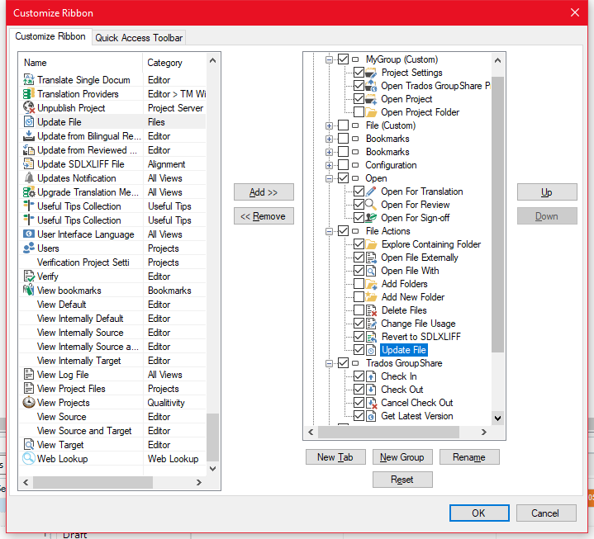
After restarting Studio
After Ribbon Customization of Project View
After restarting Studio again

Project View
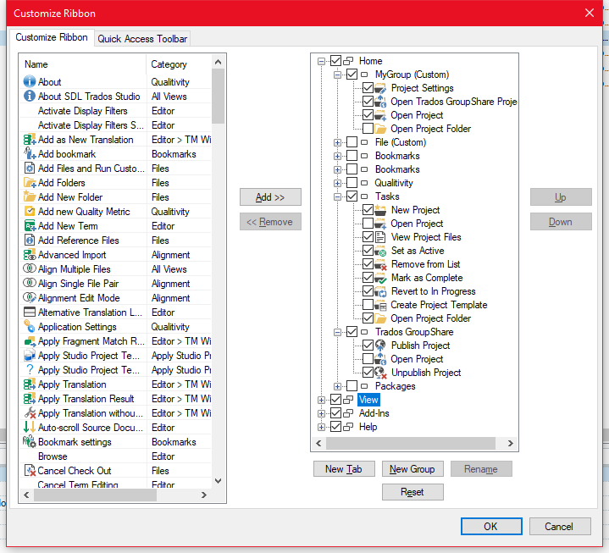
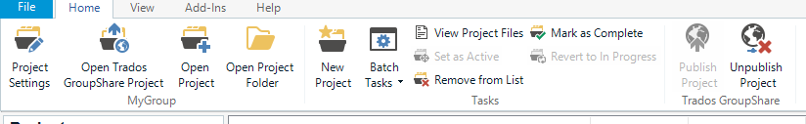
After restarting Studio
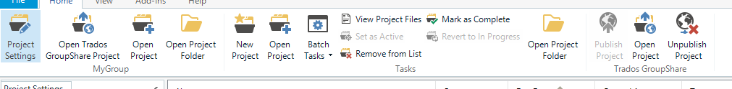
After restarging Studio again (after Ribbon Customization of file view)
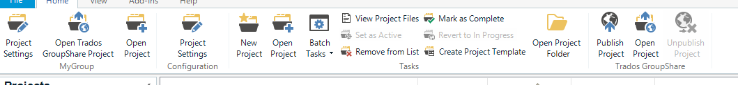
File View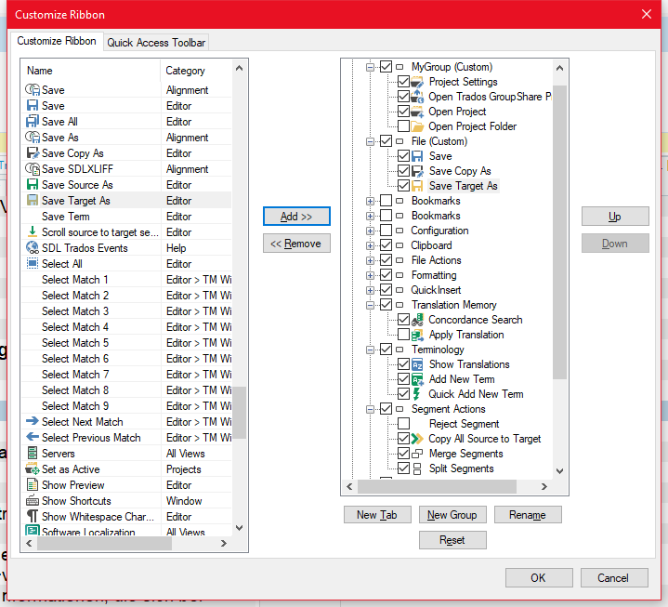
After closing document
After restarting Studio

