Project View, a few examples.
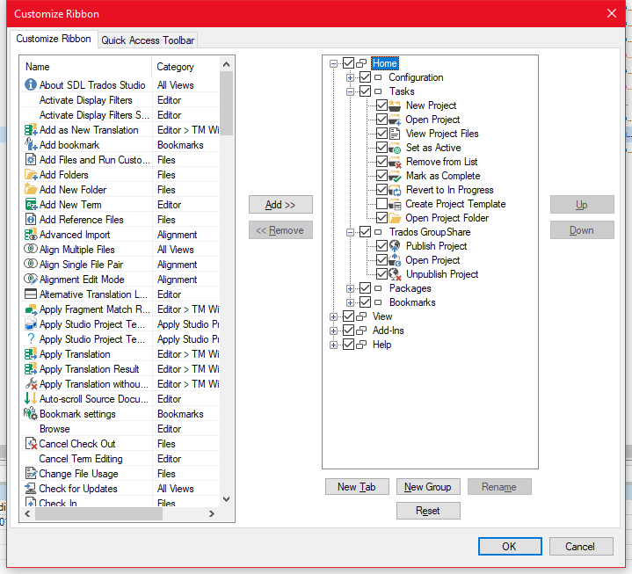
The only change I made is unchecking Create Project Template. After clicking OK correct.
After closing and restarting Studio I get this incorrect, the customization is gone
After resetting Ribbon, closing and opening Studio I unchecked Packages and Bookmarks
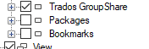
After clicking OK correct
I get the same ribbon after closing and restarting Studio, but in Ribbon Customization the group Bookmarks has moved to the top:
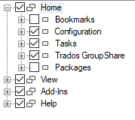
After resetting Ribbon, closing and opening Studio I unchecked 3 features and inserted the same features in group Configuration. At the same time, I deactivated “Create Project Template”:
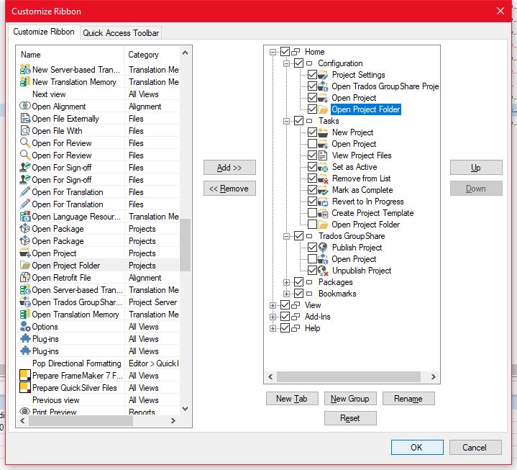
After clicking OK correct
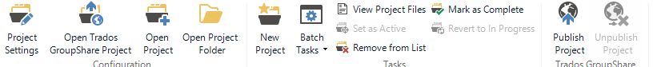
After restarting Studio not correct
