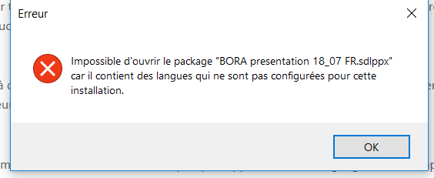

SDL Trados Studio Project Package
sdlppx (package project)

