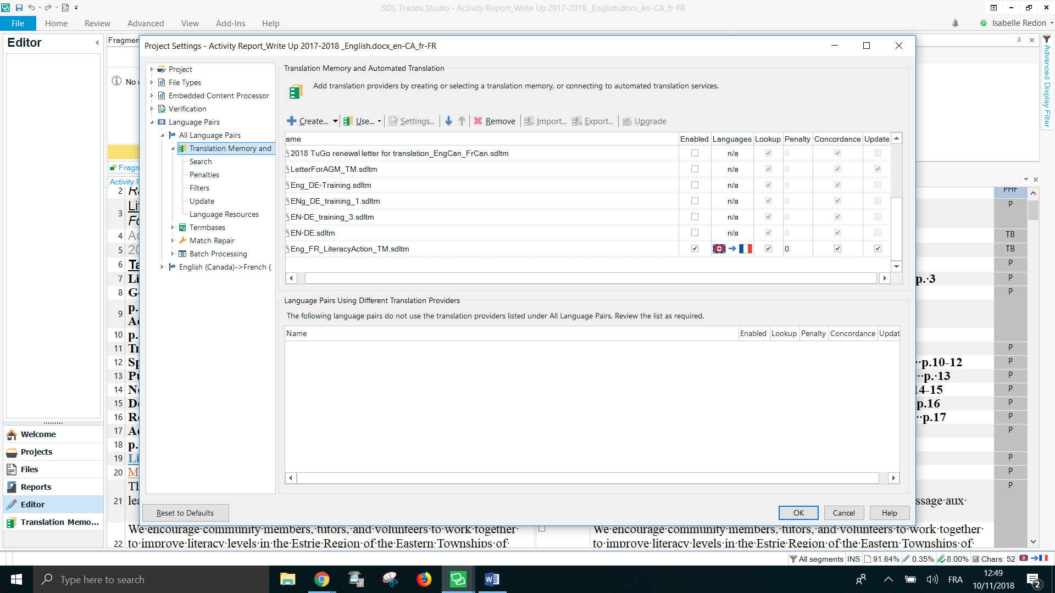
This is my TM at the bottom, update is ticked:

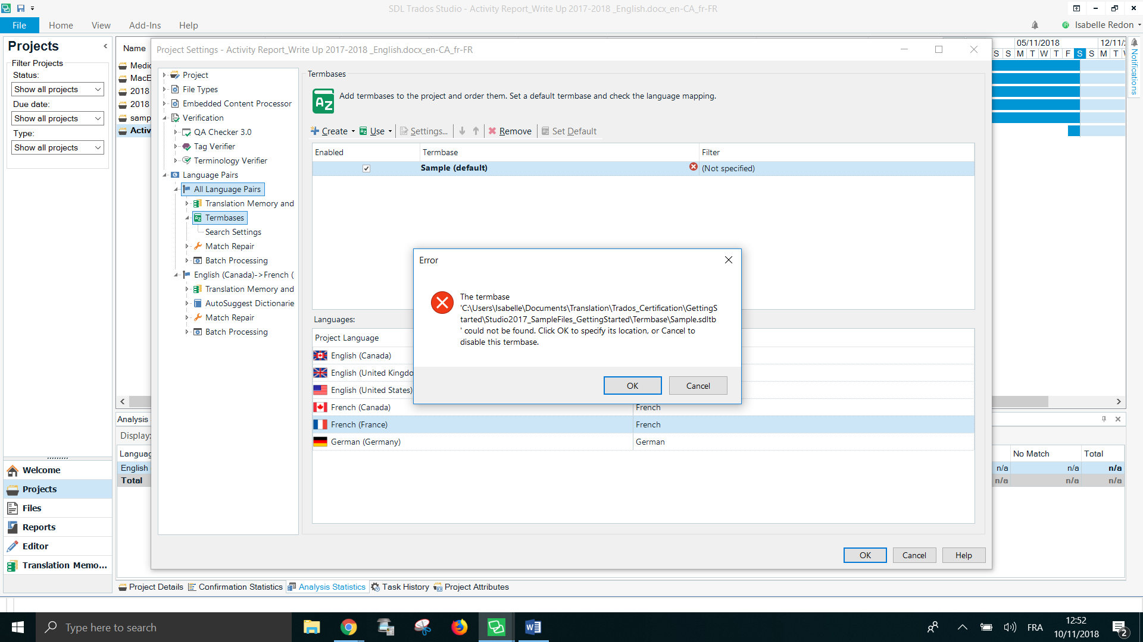
This is what comes up when I went into the termbase

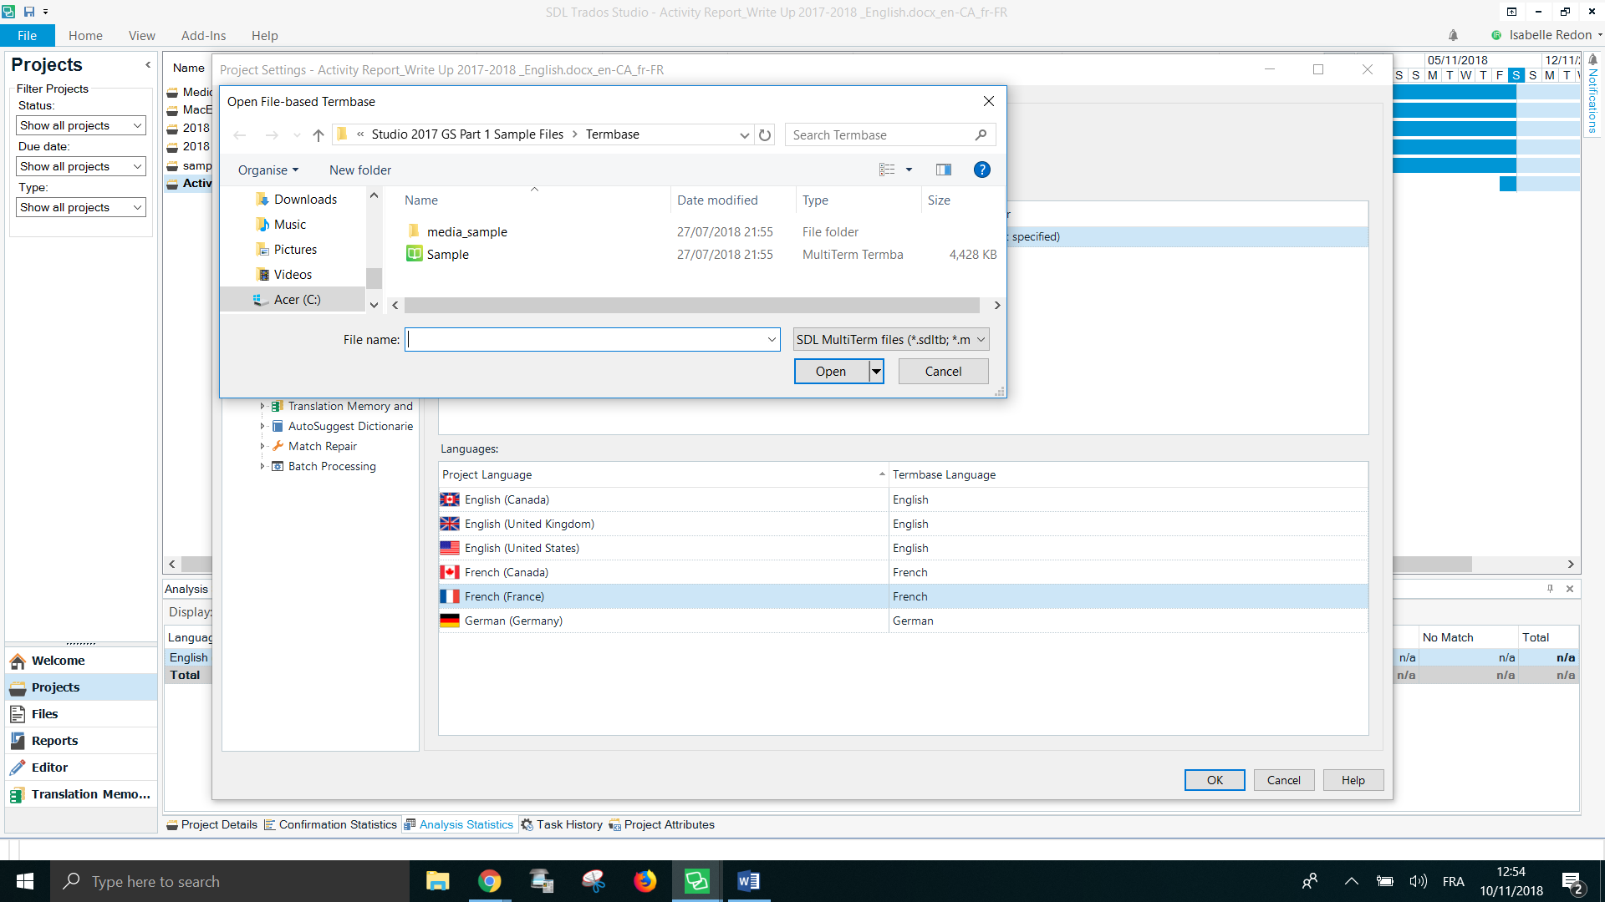

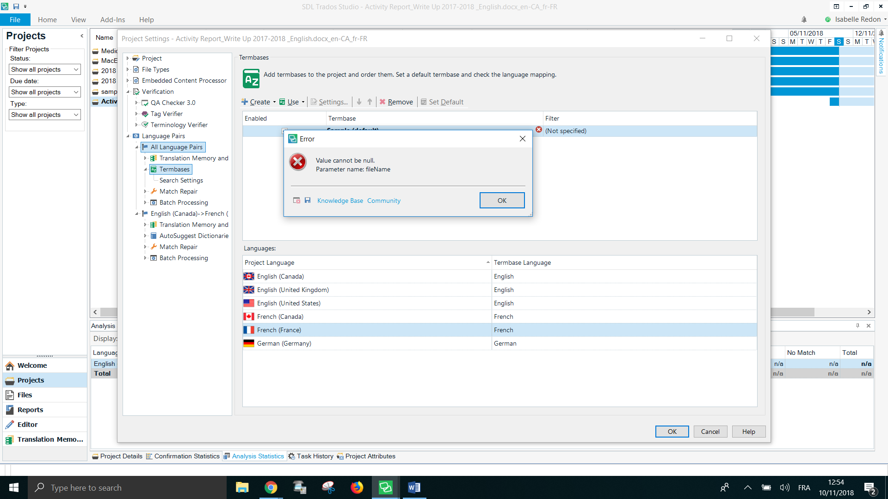
I unticked Sample term base, still an error message

On the plus side, I now remove the term base and the message doesn’t occur anymore.
But re my TM, it’s still not doing its job. For ex, seg 46 has the word publicity that I’ve translated in earlier segments but it’s not finding any match. Why? The TM is not remembering any of the content of the segments.
